Chapter 10 & 12 Notes- Stoichiometry
__________________________ – A fraction equal to 1 that is used to change one unit into another. (When the numerator = denominator, a fraction equals 1.)
_________________________ – A problem solving method where conversion factors are used to cancel unwanted units.
a) Convert $25 to nickels.

b) Convert 180 days to seconds.

Common Conversions to Know
1 base (m, l, g) = 100 _____ .
1 base (m, l, g) = 1000 ____ .
1 ____ = 1000 base units (m, l, g)
c) Convert 125 cm to km.

d) Convert 15 m/s to km/hr.

Measuring Matter
How do we describe how much of something we have?
By ___________________, by _________________, by ___________________.
We use words like “dozen” to talk about an amount.
In chemistry, we use the ________________.

Mole
_______________________ – SI unit for measuring an amount of a substance.
A “particle” will either be:
An atom, a molecule or a formula unit
______________________________________________ = 6.02 x 10²³
_____________________________ = smallest unit that still has all the characteristics of that substance.
Representative Particles
What is the representative particle of :
- Element (ex. Cu): ____________________
Exception: The representative particle of the 7 diatomic elements is a molecule. (ex. H₂)
- Covalent compound (ex. H₂O): __________________
- Ionic Compound (ex. NaCl): _______________________

4 moles Ca = atoms Ca.

5 x 10¹⁸ atoms Cu = moles Cu.

9.2 moles F₂ = molecules F₂?

9.2 moles F₂ = atoms F?
Molar Mass
________________________________ – The mass of one mole of an element or compound.
Molar mass of a compound = the sum of the masses of the atoms in the formula.
Use the atomic masses in ________________________on the periodic table.
Find the molar mass of each:
Sr

MgBr₂

Ba₃(PO₄)₂

Mole–Gram Conversions
1 mole = ____________________________________________________
5.3 moles LiOH = ___________ grams LiOH (Molar mass LiOH : 7 + 16 + 1 = ______ g/mol)

68 grams F₂ = moles F₂?

STP
__________________= Standard Temperature & Pressure
  - Standard Temp 0ºC
  - Standard Press 1 atm

Molar Volume of a Gas
_______________________________________________: equal volumes of gases at the same temperature and pressure contain equal numbers of particles.
At STP, 1 mole of any gas occupies a volume of ___________________ L.
___________ mole = _____________ L (of gas at STP)

5.4 moles He = L He at STP?

Molar Mass-Density Conversions
Density = $\frac{grams}{Liter}$ Molar Mass = $\frac{grams}{mole}$
A gaseous compound composed of sulfur and oxygen has a density of 3.58 g/L at STP. What is the molar mass of this gas?

What is the density of Krypton gas at STP?

Multi-step Problem: Example 1
If you had 5.0 L of CO₂ how many grams would that be?
Step 1: L moles
Step 2: moles grams

$\frac{5.0 L CO2 }{}$ x $\frac{1 mole CO2}{22.4 L CO2}$ x $\frac{44.0 g CO2 }{1 mole CO2 }$ =

Multi-step Problem: Example 2
How many molecules are in 60.0 grams of water?
Step 1: grams moles
Step 2: moles molecules

Percent Composition
________________________________ - % by mass of each element in a compound
Percent = $\frac{Part}{Whole}$ x 100 Percent Composition = $\frac{Mass of 1 element}{Mass of compound}$ x 100
Ex) Find the mass percent composition of Al₂(SO₄)₃

Ex) Find the percent composition of NiSO₃

More Percents
Ex) Which of the following shows a compound that is 92.3%C and 7.7%H?
a) C₂H₄ b) C₃H₆
c) CH₄ d) C₆H₆
Empirical and Molecular Formulas
____________________________________ – The simplest formula.
Shows the smallest whole number ratio of elements in a compound.
Covalent formulas will not always be empirical.
Example: CH
___________________ Formula – The actual formula.
For ionic compounds – it will be the simplest ratio.
For molecular compounds – it will NOT always be the simplest ratio.
Example: C₆H₆
Empirical Formula
Calculate the empirical formula of a 2.5 gram compound containing 0.90g Ca and 1.60g Cl.
Step 1: Convert GRAMS to MOLES.

Step 2: DIVIDE the # of moles of each substance by the smallest number to get the simplest mole ratio.

Step 3: If the numbers are whole numbers, use these as the subscripts for the formula. If the numbers are not whole numbers, multiply each by a factor that will make them whole numbers.
Look for these fractions:

What is the empirical formula of a compound that is 66% Ca and 34% P?
Step 1: grams moles

Step 2: Divide by the smallest.

Determining Molecular Formulas
A compound has an empirical formula of CH₂O. Its molecular mass is 180g/mol. What is its molecular formula?
Step 1: Find the mass of the empirical formula.

Step 2: Divide the molecular mass by the mass of the empirical formula to get the “multiplying factor”.

Step 3: Multiply each of the subscripts in the empirical formula by this factor to get the molecular formula.

Find the molecular formula of ethylene glycol (CH₃O) if its molar mass is 62 g/mol.

The percent composition of methyl butanoate is 58.8% C, 9.8% H, and 31.4 % O and its molar mass is 204 g/mol.
What is its empirical formula? What is its molecular formula?

Empirical Formula C₅H₁₀O₂
Mass = 5(12) + 10(1) + 2(16) = 102 g/mole
$\frac{Molecular mass-→}{Empirical mass-→}$ $\frac{204 g/mol}{102 g/mol}$ = 2
So molecular formula is 2 x emp. form: 2(C₅H₁₀O₂) = C₁₀H₂₀O₄
Stoichiometry
_________________________ – The calculations of quantities of substances involved in chemical reactions
___________________ in a balanced reaction show the MOLE TO MOLE RATIO.
  - Ex. 1N₂ + 3H₂ 2NH₃
There is a mole ratio
Note – Don’t use coefficients when adding up the mass!
Mole-Mole Conversions
2A + B 3C + 7D
Given the number of moles of reactant A (6 moles), you can find:
1)

2)

3)

N₂ + 3H₂ 2NH₃
If you have 2 moles of N₂, how many moles of NH₃ will be produced?

Reaction Conversions
****The only way to convert from one compound to something totally different in the reaction is to use the ___________________________________________ from the coefficients!!!****
Note – If you don’t have moles already, your first step is to convert to moles!
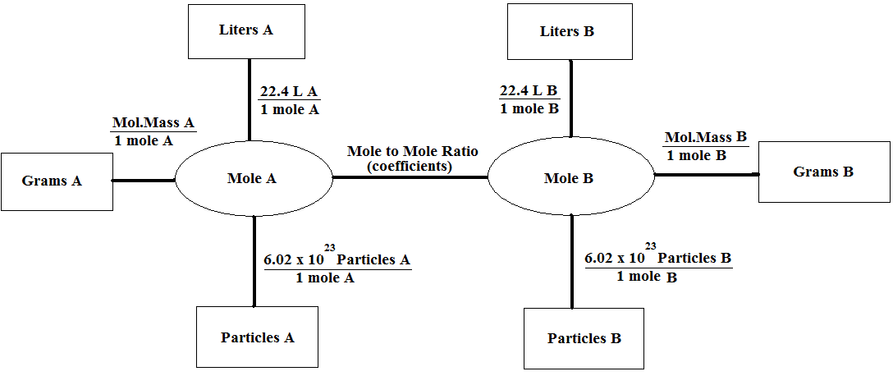
Mass-Mass Conversions
How many grams of hydrogen gas are required for 3.75g of nitrogen gas to react completely?
(Order: grams N₂ mole N₂ mole H₂ grams H₂ )

N₂ + 3H₂ 2NH₃
How many grams of H₂ are required to produce 5.0 grams of NH₃?
(Grams NH₃ moles NH₃ moles H₂ grams H₂ )

Mass – Volume Conversions
C₂H₄ + 3O₂ 2H₂O + 2CO₂
How many liters of CO₂ (at STP) would be produced from the combustion of 4.0 grams of C₂H₄?

C₂H₄ + 3O₂ 2H₂O + 2CO₂
How many liters of O₂ would be needed to produce 6.8 grams of H₂O?

Volume – Volume Conversions
N₂ + 3H₂ 2NH₃
How many liters of ammonia (NH₃) would be produced from 8.0 liters of hydrogen?

N₂ + 3H₂ 2NH₃
How many liters of N₂ would be needed to produce 15.0 liters of NH₃?

